Business Question and Visualization Report

Date | 22 September 2026
Team ID | MCA
Project Name | Strategic Employee Attrition Intelligence Dashboard
Maximum Marks | 5 Marks

Visualization development refers to the process of creating graphical representations of data to facilitate understanding, analysis, and decision-making. The goal is to transform complex datasets into visual formats that are easy to interpret, enabling users to gain insights and make informed decisions. Visualization development involves selecting appropriate visual elements, designing layouts, and using interactive features to enhance the user experience. This process is commonly associated with data visualization tools and platforms, and it plays a crucial role in business intelligence, analytics, and reporting
Business Questions and Visualisation
The process involves defining specific business questions to guide the creation of meaningful and actionable visualizations in Power BI. Well-framed questions help in identifying key metrics, selecting relevant data, and building visualisation that provide insights.

Business Questions | Visualization | Screenshot
Which departments experience the highest rate of employee attrition? | Horizontal Bar Chart comparing Attrition Rate by Department. | 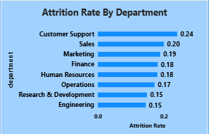
Which specific job roles are most impacted by high attrition rates? | Horizontal Bar Chart displaying Attrition Rate across Job Roles. | 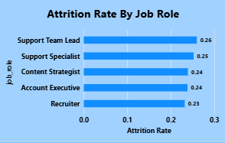
How does the usage of AI tools impact employee attrition rates? | How does the usage of AI tools impact employee attrition rates? | 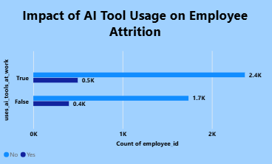
How do organizational slicers allow filtering of attrition metrics by Work Mode, Department, and Job Role? | Slicer control panel containing drop-down filters for Work Mode, Department, and Job Roles. | 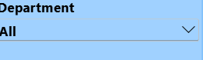
How does compensation growth influence employee attrition across different salary hike percentage bands? | Horizontal Bar Chart displaying Attrition Risk Across Salary Growth Bands. | 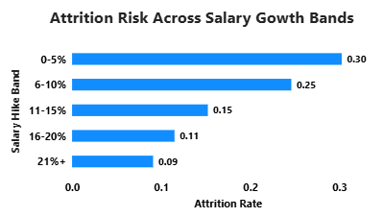
How does employee turnover probability change over time as years at the company increase? | Line Chart showing Employee Attrition Across Tenure Journey (Years at Company vs Attrition Rate). | 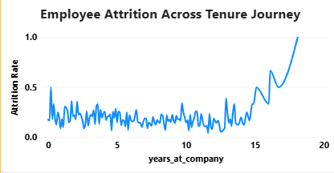
How does employee attrition rate fluctuate across different job levels and career stages? | Line Chart charting Attrition Trends Across Career Levels (Job Level vs Attrition Rate). | 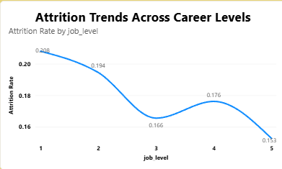
Which department accounts for the highest proportion of employee attrition in the company? | Donut Chart displaying Department Wise Attrition Rate across Customer Support, Sales, Marketing, Finance, HR, Operations, R&D, and Engineering. | 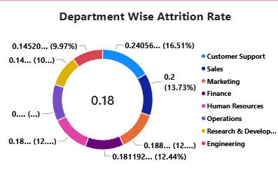
What is the relationship between training investment (mapped against burnout score bands) and attrition rate? | Line Chart showing Attrition Risk by Training Investment across Burnout Score Bands. | 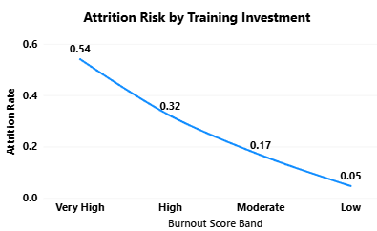
How does marital status (Married, Single, Divorced) impact employee retention and attrition counts? | Stacked Bar Chart displaying Employee Retention By Marital Status (Count of employee_id by Marital Status and Attrition status). | 